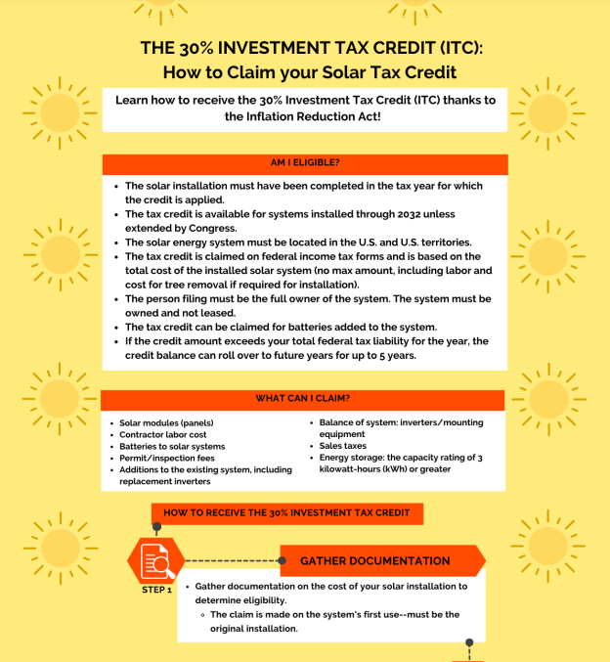

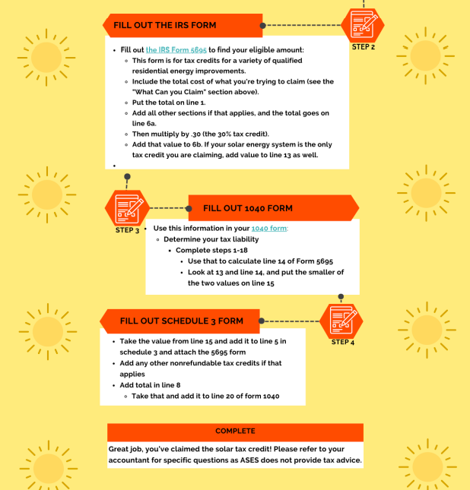

Energy Sage: https://news.energysage.com/how-do-i-claim-the-solar-tax-credit/
IRS: https://www.irs.gov/e-file-providers/line-by-line-instructions-free-file-fillable-forms
IRS Form 5695: https://www.irs.gov/forms-pubs/about-form-5695

