Geil Homestead
Renewable Energy Components
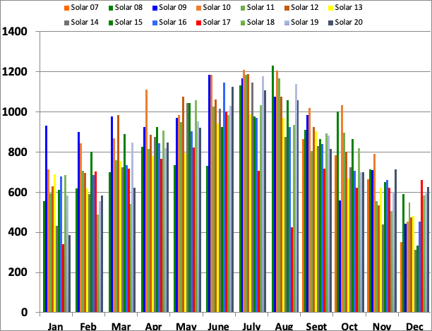
Solar energy production of original 8kW (44) Evergreen 180W panels, currently Enphase micro inverters; to 1/1/21

Solar energy production of 8 kW (32) Helios 250W panels, installed Dec, 2012, with Enphase microinverters; to 1/1/21

Solar energy production of 5.7kW (20) Suniva 285W panels, installed April 13, 2016, all with Enphase microinverters, to 1/1/21

Wind energy production of 10 kW Bergey Excel turbine on 100’ tower, installed March, 2007; to 1/1/21 Inverter replaced in June-July 2018
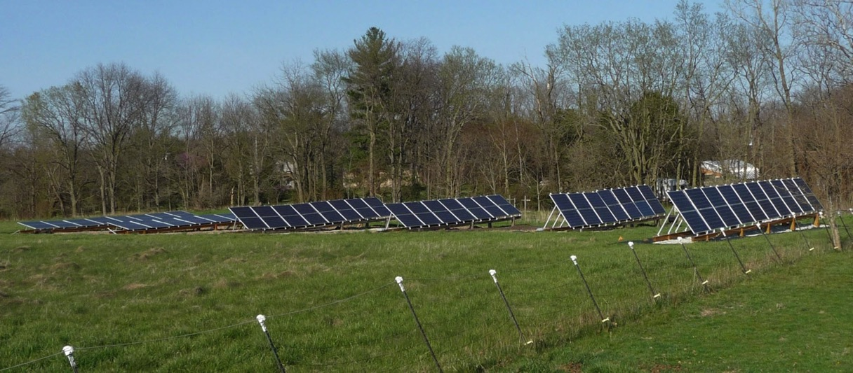
Helios (2 rows, 32), Evergreen (3 rows, 44) and Suniva (1 row, 20) panels, at optimum summer, spring and fall and winter tilts (12, 38 and 65°)
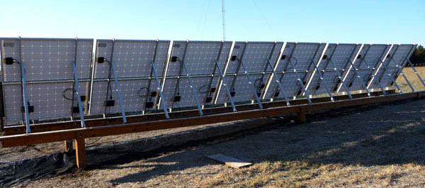
Enphase microinverters on Helios panels

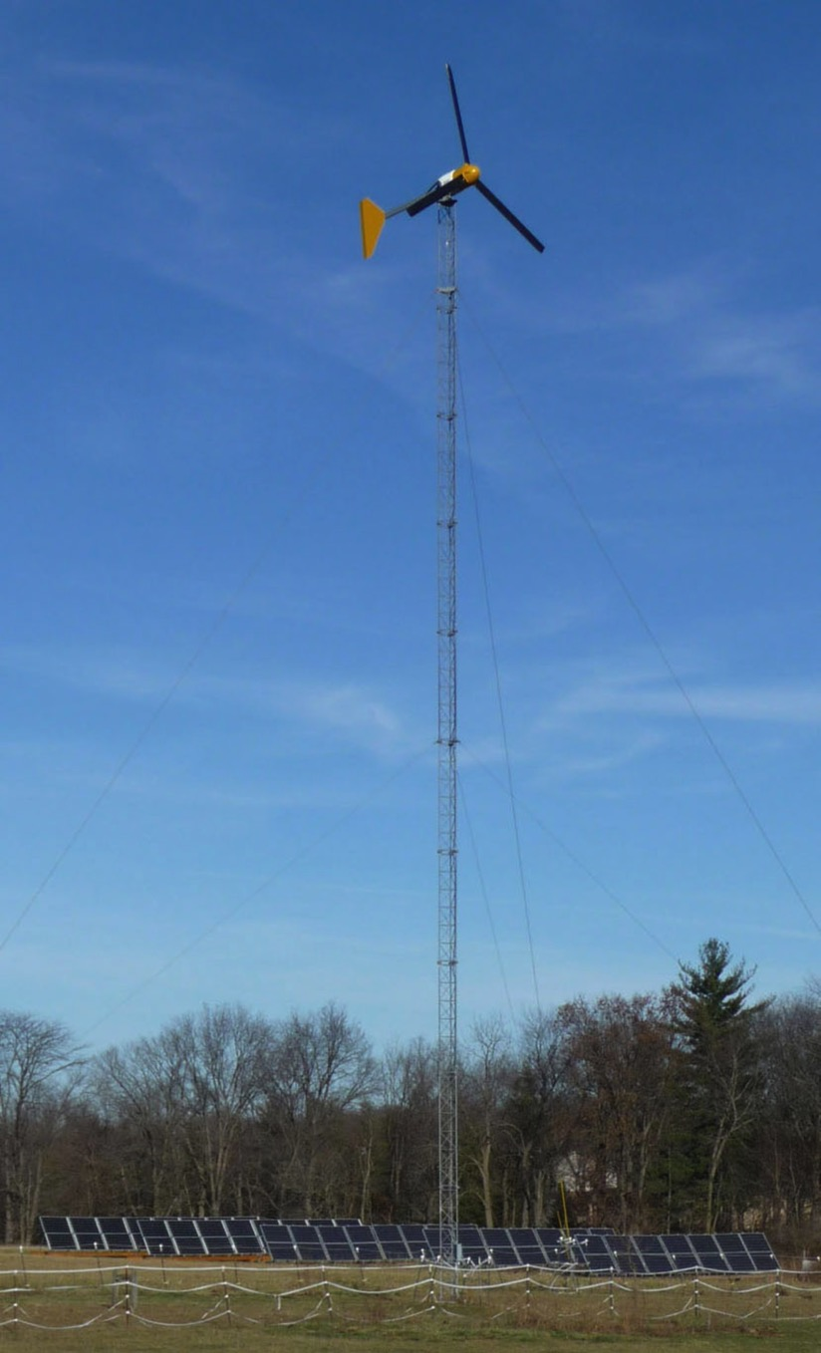
Bergey 10 kW Excel Turbine

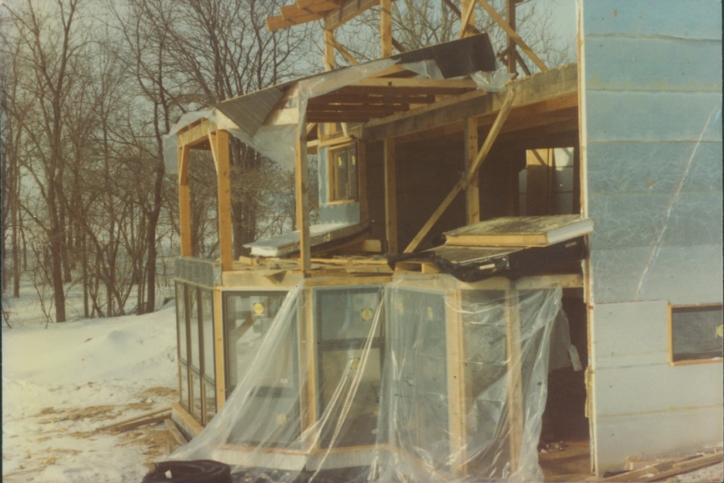
Timber frame construction with SIP panels

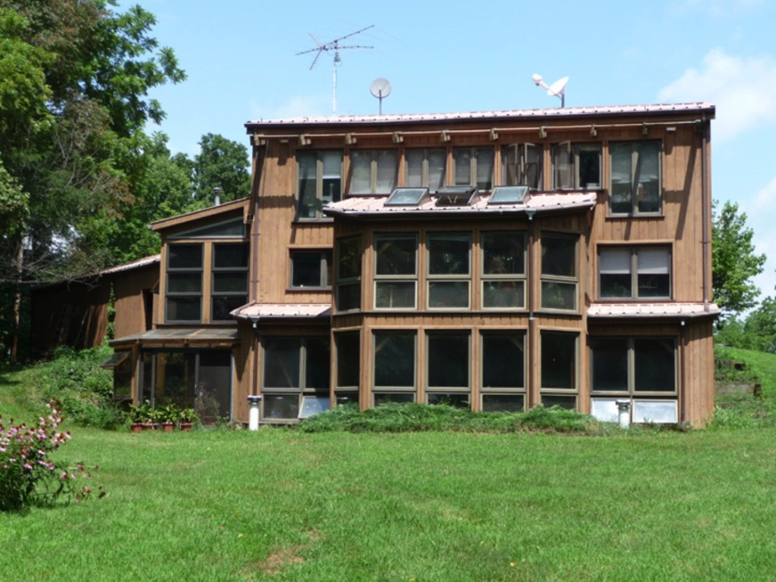
Completed, south facing, earth sheltered, passive-active solar
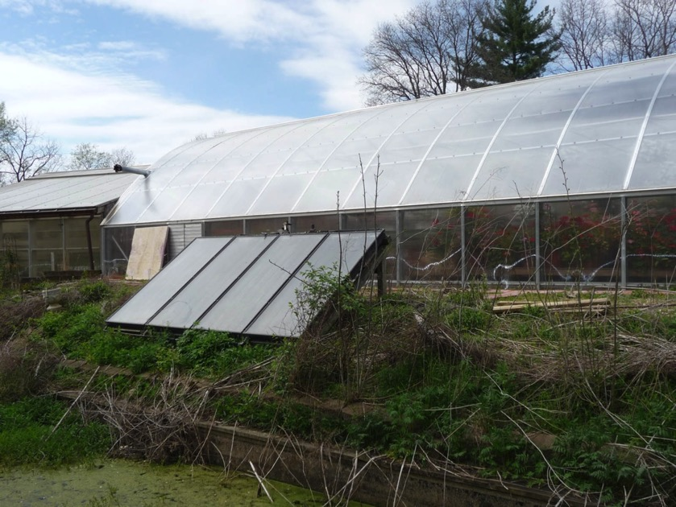
Solar thermal panels for swimming pool in greenhouse

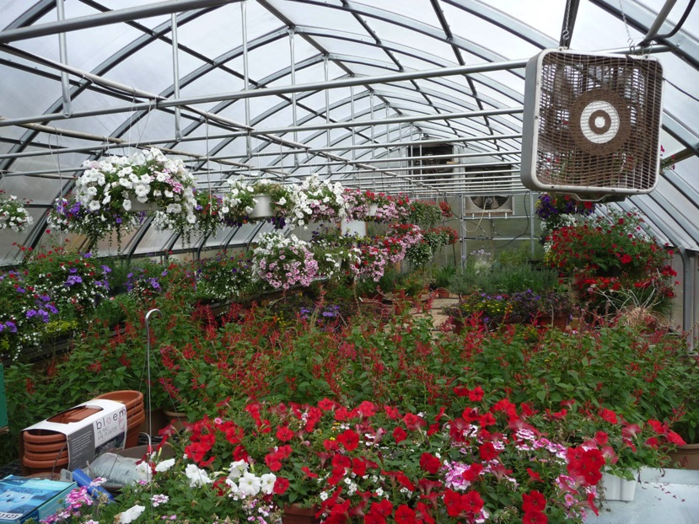
Interior of polycarbonate twin wall covered greenhouse; beams and panels cover the pool
Total production to date (1/1/21): Wind (10 kW) from 2/9/07 – 84672 kWh; Evergreen solar (6.8 kW +1.2 kW on 7/16/08) from 8/16/07 – 129467 kWh. Helios solar (8 kW) from 11/23/12 – 89406 kWh. Suniva solar (5.7 kW) from 4/13/16- 35395 kWh. (Wind inverter repair 3/29/09-5/8/09 and 6/10/18 -7/25/18)
Annual production in kWh: 2008 Wind 8,262, E. Solar 9,739; 2009 Wind 5,434, E. Solar 10,732; 2010 Wind 5686, E. Solar 11,380; 2011 Wind 6210, E. Solar 9991; 2012 Wind 5,998, E. Solar 10,367; 2013 Wind 6105, E. Solar 9,229; H. Solar 11,473; 2014 Wind 5830, E. Solar 9202, H. Solar 11,412. 2015 Wind 5197; E. Solar 9948; H. Solar 12095. 2016 Wind 5909; E. Solar 9548; H. Solar 11583; S. Solar (from 4/13/16) 5068. 2017 Wind 6601, E. Solar 8106, H. Solar 9818, S. Solar 7047. 2018 Wind 5382, E. Solar 9435, H. Solar 11203, S. Solar 8035. 2019 Wind 6186, E. Solar 9883, H. Solar 10350, S. Solar 7764. 2020 Wind, 6331, E. Solar 9501, H. Solar 10270, S. Solar 7481 (E = Evergreen, H = Helios, S = Suniva)
Total installed costs: Wind ~ $45,000; Evergreen solar ~$35,000 – $10,000 State grant and $2,000 Federal rebate + ~$4,500 - $1,600 State grant and $1600 Federal rebate = Total Evergreen solar ~ $39,500 – $15,200 = $25,300. Helios solar ~ $22,000 - $5,400 State grant and $6,600 Federal rebate ≈ $10,000. Suniva solar $9940 – $2980 Federal = ca. $6960. Maintenance: Wind ca. $300/yr, Solar negligible. Wind inverter replacement, 2018 $7200. SRECs payments received; 2008, for Evergreen (8kW) from Naperville $584.88. Current $94.80/MWh for Evergreen and Helios since Sept. 2016 ($4410.92 for Evergreen and $5453.72 for Helios), $5/MWh (non-self-bonded) for wind ($424.80, bond repayment, 10/30/18), $190/MWh for Suniva since 5/30/17. ($5320)
Wind system – Bergey 10 kW turbine on 100’ tower; Xantrex inverter replaced by Bergey, 2018. Solar system – 40 180 W + 4 190 W blemished Evergreen thin film panels, 3 refurbished 3.3 kW Xantrex inverters; 32 250 W Helios monocrystalline panels with M215 Enphase inverters; 20 285W Suniva panels with M250 Siemens (Enphase) inverters, UniRac and home built struts. One central inverter replaced with Enphase M190 inverters in Feb, 2014 due to panel short. Others replaced in 2016 and 2017. Panels are retilted 4 times/year, at 12, 38, 65° and 38° (summer, fall, winter and spring), resulting in 13% greater production than installer estimated values for a 30° tilt ground mount and 33% greater than for a 14° tilt roof mount.
For information on house construction (earth sheltered, solar heated, geothermal with ERV and 260’ ground loop, low voltage switching, on-demand gas hot water, fluorescent and LED lighting, timber frame with R50 wall, R70 roof self built SIP panels) see http://www.flickr.com/photos/geil-homestead
For more information on the above: phgeil@gmail.com

